Project Documentation
1. Project Title : AUTO TICKET CLASSIFICATION USING FLOW DESIGNER
Team ID : SWTID-2026-6043
Team Leader : ASMIRATHI S
Leader Mail ID : 202400063@sigc.edu
Team Members :
- ABIRAMI G - 202400311@sigc.edu
- BAVANA SRI S -202400881@sigc.edu
- ELAKKIYA S - 202400361@sigc.edu
2. Abstract :
Educational institutions receive many IT support requests every day, such as Wi-Fi failures, projector problems, forgotten passwords and slow computers. Classifying each ticket by hand delays the response and often leads to wrong categories. The proposed Auto Ticket Classification system uses Service Now Flow Designer to read the short description of a newly created ticket, identify keywords, and automatically assign the correct Category and Subcategory. An email confirmation is then sent to the caller. The solution is completely no-code, easy to maintain and reduces the manual effort of IT staff.
3. INTRODUCTION :
ServiceNow is a cloud-based platform used to manage IT service requests, incidents and workflows. Flow Designer is its no-code automation tool, which lets developers build automated processes using triggers, conditions and actions. In this project, a custom table named Incident Workflow stores the school IT tickets, and a flow named Auto Classify School IT Tickets runs each time a new ticket is created. The flow checks the ticket text and updates the record without any human intervention.
4. Problem Statement :
The school IT helpdesk receives multiple incident requests daily from students and teachers. IT staff must manually review every request, choose the category and subcategory, and inform the caller that the ticket was created. This process is time-consuming, error-prone and not scalable as the number of requests grows. A system is needed that classifies tickets automatically at the time of creation.
5. Objectives :
- Automatically classify incidents at the time of creation.
- Reduce the manual effort of IT agents.
- Improve ticket routing efficiency.
- Assign Category and Subcategory using dependent choice logic.
- Notify the caller by email after ticket submission.
- Implement a no-code, easily maintainable solution.
6. Existing Systems :
In the existing approach, the student or teacher raises a ticket and an IT staff member reads it, selects the category and subcategory manually, and then informs the caller. The quality of classification depends on the person handling the ticket.
Limitations
- Time-consuming manual review.
- Inconsistent or wrong categories.
- Delay in ticket routing and response.
- Not scalable for a large number of tickets.
- No automatic confirmation to the caller.
7. Proposed System :
The proposed system automates classification using Flow Designer. The user only enters the Caller and the Short Description. When the record is created, the flow is triggered and checks the Short Description for keywords such as Wi-Fi, Network, Projector, Forgot Password and Slow Computer. Based on the match, an Update Record action sets the Category and Subcategory. Finally, a Send Email action informs the caller that the request has been submitted.
8. System Architecture :
The system follows an automated processing pipeline:
New Ticket Created
↓
Flow Trigger (Record Created)
↓
Keyword Check (If / Else-If)
↓
Update Record (Category & Subcategory)
↓
Send Email to Caller
The request passes through three major stages:
- Trigger – Starts the flow when a record is created in the Incident Workflow table.
- Condition Check – Compares the Short Description with predefined keywords.
- Action – Updates the record and sends the confirmation email.
9. System Execution Flow :
- Step 1 – Ticket Creation :
The user creates a ticket by entering the Caller and Short Description.
- Step 2 – Flow Trigger :
The flow Auto Classify School IT Tickets starts when the record is created and the Category is empty.
- Step 3 – Keyword Evaluation :
The If / Else-If conditions check the Short Description for the required keywords.
- Step 4 – Record Update :
The matching branch updates the Category and Subcategory.
- Step 5 – Email Notification :
A confirmation email is sent to the Caller.
10. Methodology :
The project was implemented in the following phases:
- Update Set – A local Update Set named Project Update Set (Application: Global) was created and made current to track all changes.
- Custom Table – The table Incident Workflow (u_incident_workflow) was created with Auto Number enabled.
- Fields – Number, Caller, Category, Subcategory, Short Description, Description, State, Assigned Group and Assigned to were added through Form Design.
- Dependency – Subcategory was made dependent on Category using Configure Dictionary.
- Flow – The flow uses the trigger Record Created on the Incident Workflow table with the condition Category is Empty.
Classification rules used in the flow:
If Short Description contains | Category | Subcategory
Wi-Fi or Network | Network | Wi-Fi
Projector | Hardware | Projector
Forgot Password | Access | Forgot Password
Slow Computer | Performance | Slow Computer

Table fields used:
Field Label | Type | Reference / Choice
Number | Auto Number | —
Caller | Reference | sys_user
Category | Choice | Network, Hardware, Access, Performance
Subcategory | Choice | Wi-Fi, Projector, Forgot Password, Slow Computer
Short Description | String | —
Description | String | —
State | Choice | New, In progress, On hold, Resolved, Closed
Assigned Group | Reference | sys_user_group
Assigned to | Reference | sys_user
11. Key Features :
- Automatic Classification
Category and Subcategory are set without manual selection.
- Dependent Choices
Available Subcategory options depend on the selected Category.
- Email Notification
The caller receives an instant confirmation after submission.
- No-Code Solution
Built entirely with Flow Designer, so it is easy to maintain and scale.
12. Hardware Requirements :
- Computer with a minimum of Intel Core i3 processor
- Minimum 8 GB RAM
- Stable internet connection
13. Software Requirements :
- ServiceNow Personal Developer Instance (PDI)
- ServiceNow Flow Designer / Workflow Studio
- Web browser (Google Chrome)
14. System Comparison :
Feature | Manual Classification | Auto Classification (Flow Designer)
Classification | Done by IT staff | Done automatically
Speed | Slow | Instant
Accuracy | Prone to human error | Consistent
User Notification | Manual | Automatic email
Scalability | Low | High
15. Advantages :
- Saves time and reduces manual effort.
- Gives consistent and accurate classification.
- Speeds up ticket routing.
- Keeps users informed with automatic emails.
- No coding required and easy to maintain.
16. Future Scope :
The project can be enhanced with:
- Auto-Assignment – Assign tickets automatically to the correct support group.
- Priority Setting – Set ticket priority based on the issue type.
- More Categories – Add more keywords and categories for other IT problems.
- AI-Based Classification – Use machine learning to understand the ticket text instead of fixed keywords.
Output Screen :
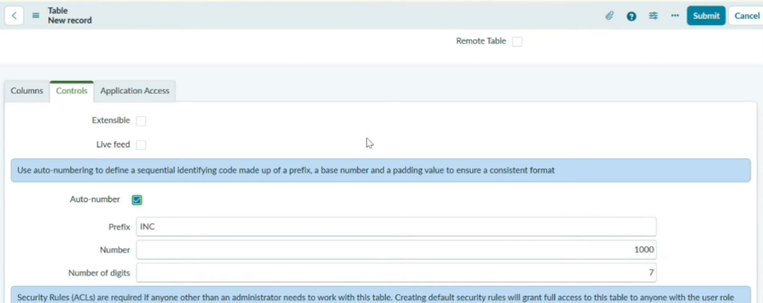
Fig 1: Incident Workflow table with Auto Number enabled
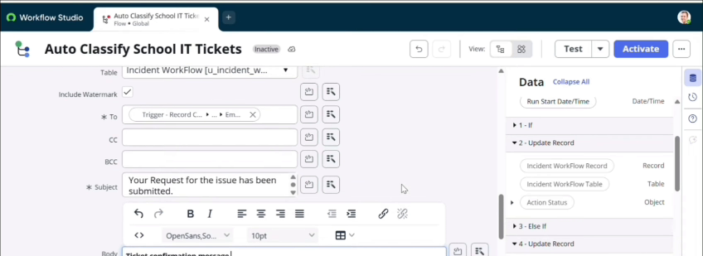
Fig 2: Send Email action in the flow
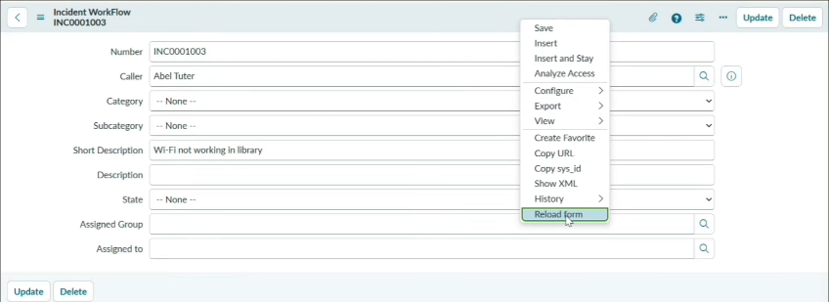
Fig 3: Test ticket – "Wi-Fi not working in library"
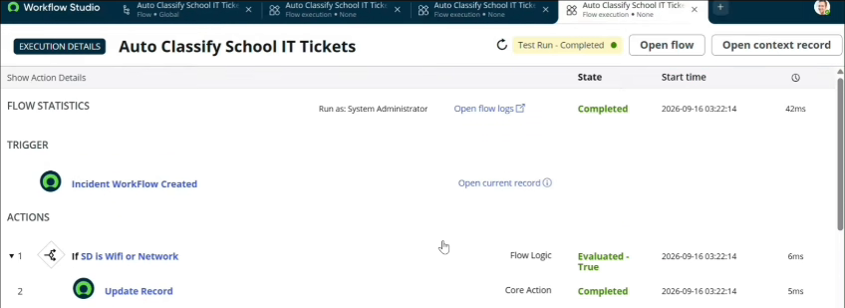
Fig 4: Flow execution details – Test Run Completed
17. Conclusion :
The Auto Ticket Classification system automatically assigns the Category and Subcategory of school IT tickets using ServiceNow Flow Designer and informs the caller by email. Testing with the ticket "Wi-Fi not working in library" confirmed that the Wi-Fi condition evaluated true, the record was updated and the flow completed successfully. The solution reduces manual work, avoids classification errors and provides faster support in a maintainable, no-code way.
18. Reference :
Demo Video Link :
Github Link :

